IN 32
ELECTRONIC PATIENT CARE BED, 3 MOTORS
- Electrical operated backrest, height and legrest adjustment
- Fowler and Vascular positions
- Hand remote control
- Detachable PP head and foot boards
- Auto-contour
- Easily cleanable, lockable and fold-away PP side rails
- Auto-regression system for backrest
- Easy removable ABS mattress platform
- Angle indicator for backrest
- Electrostatic powder coated metal frame
- Footrest adjustment by ratchet
- Height adjustable IV pole
- Protective plastic corner bumpers
- 125 mm diagonal lockable castors
- 125 mm central lockable castors (optional)
- Dual side manual CPR levers at backrest (optional)
- Bed Extension (optional)
- Battery backup (optional)
- IPX6 standard electronic system
Other Electrical Hospital Beds products
 | TECHNICAL DETAILS
 | Overall Length | : 216 cm
 | Overall Width | : 102 cm
 | Height Range | : 42-84 cm
 | Backrest Angle | : 0°-70°
 | Legrest Angle | : 0°-35°
 | Castor Diameter | : 12,5 cm
 | Under Bed Clearance | : 12,5 cm

 | Product Weight | : 100 kg
 | Safe Working Load | : 200 kg
—
 | ELECTRICAL DATA
 | Power In | : 1.5A max. At 230V AC 50-60 Hz
 | Electrical Shock Protection | : Class I, Type B
 | Liquid Ingress Protection | : IPX6

ACCESSORIES
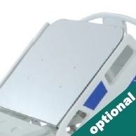
X-Ray Translucent Backrest with Cassette Holder
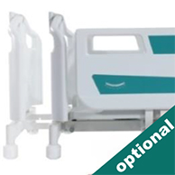
Bed Extension
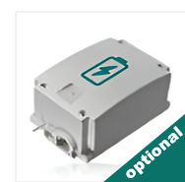
Rechargeable Battery Backup
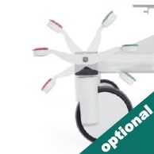
Central Brake Castors 150 mm
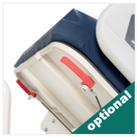
Dual Sided Manual CPR at Backrest
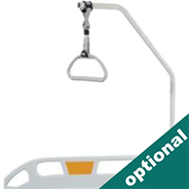
Lifting Pole
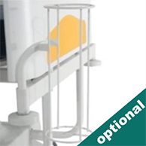
Oxygen Cylinder Holder
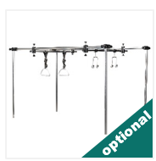
Orthopedic Traction System
COLOR CHART
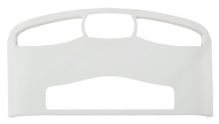
P01
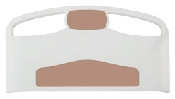
P02
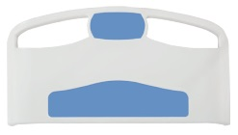
P03
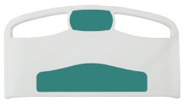
P04
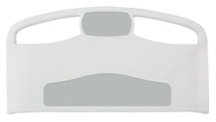
P05
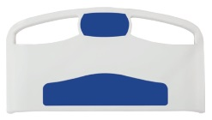
P06
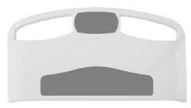
P07
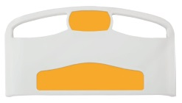
P08

